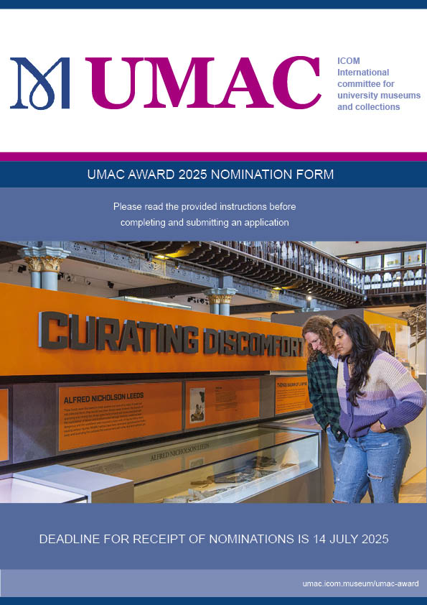

# HOW TO NOMINATE

Please complete this form. Except for a short description, all information supplied will be treated as strictly confidential and used only by the Evaluation Panel for the purpose of selecting the winner.

This form, once completed, must be emailed to [secretary.umac@icom.museum](mailto:secretary.umac@icom.museum)

You may include any additional information to support your nomination, such as pictures, files, testimonials with your emailed nomination form.

You will receive a confirmation of safe receipt for you emailed entry. If you have not received this within 48 hours please get back in contact with us. These entries will all be forwarded to the UMAC Award Chair once the submission deadline has arrived.

The deadline for nominations is COB Monday, 14 July 2025.

Read the UMAC AWARD RULES carefully before you start.

<http://umac.icom.museum/umac-award/rules>

Queries relating to the nomination process should be emailed to the UMAC Award Chair

Akiko Fukuno  
[fukuno@icu.ac.jp](mailto:fukuno@icu.ac.jp?subject=Query:%202023%20UMAC%20AWARD%20nomination%20process)   
(queries only should be emailed to Akiko Fukuno– your completed nomination and supporting documentation must be emailed to [secretary.umac@icom.museum](mailto:secretary.umac@icom.museum) for registration and confirmation purposes)

*Cover image: Winner of the 2024 UMAC AWARD:  
The Hunterian, University of Glasgow  
‘Curating Discomfort’*

# NOMINATION STEPS

READ THE UMAC AWARD RULES CAREFULLY BEFORE YOU START.

Here they are: <http://umac.icom.museum/umac-award/rules>

### Step 1: CONFIRM YOU MEET NOMINATION REQUIREMENTS

The entry is submitted by two ICOM members in good standing (this means that those who nominate have paid the annual membership fees for 2025). Contact details and ICOM membership numbers will be asked in the next section. An institutional membership can only be used once, the same membership cannot be used by both nominators.

### Step 2: CONFIRM YOUR NOMINEE MEETS THE ELIGIBILITY CRITERIA *To be eligible:*

- UMAC Award is open to all university museums and collections in the world, whether they   
 are ICOM or UMAC members or not.  
- Projects or initiatives nominated must demonstrate: INNOVATION / CREATIVITY,   
 EXCELLENCE, TRANSFERABILITY of ideas that can be adopted by other university   
 museums and collections and IMPACT on the host university, the community or society at   
 large.  
- Projects or initiatives must have been active between 2023 and 2025.  
- You can nominate your own university museum or collection.  
- Projects or initiatives can be of any size.  
- Projects or initiatives can be formal or informal.

### Step 3: BEGIN SUBMISSION

It is important that your entry is clear, concise and unequivocally demonstrates how your nominee meet all the criteria above.  
You must submit the form completed in all respects - you may not send your entry in successive parts at different times. Be prepared to include all the necessary information (name of the project or initiative, name of the university museum or collection, name of the director/individual responsible, university, location, start and end dates) and detailed justifications.

Please note the Evaluation Panel's decision is final and no correspondence will be entered into.

Queries relating to the nomination process should be emailed to the UMAC Award Chair

Akiko Fukuno  
[fukuno@icu.ac.jp](mailto:fukuno@icu.ac.jp?subject=Query:%202023%20UMAC%20AWARD%20nomination%20process)

(Queries only should be emailed to Akiko Fukuno – your completed nomination and supporting documentation must be emailed to [secretary.umac@icom.museum](mailto:secretary.umac@icom.museum) for registration and confirmation purposes)

# NOMINATION FORM

Reminder: Both Nominators must be ICOM Members (Institutional or Individual) in good standing. Please note, the same institutional membership cannot be used by both nominators.

## Details of the First (1st) Nominator

|  |  |
| --- | --- |
| Name of Member |  |
| Email address |  |
| ICOM membership number |  |

## Details of the Second (2nd) Nominator

|  |  |
| --- | --- |
| Name of Member |  |
| Email address |  |
| ICOM membership number |  |

# UMAC AWARD 2025 NOMINEE

## General information about the NOMINEE

|  |  |
| --- | --- |
| Name of University Museum or Collection |  |
| Full Address |  |
| Website |  |
| Name of the person in charge (to be contacted in case the nominee wins) |  |
| Job title of person in charge (director, curator, etc) |  |
| E mail address of person in charge |  |

## Justification for nomination

|  |  |
| --- | --- |
| Name of Project/Initiative |  |
| Start and end dates |  |

## Short description (to be made public) (max. 100 words)

|  |
| --- |
|  |

## Justify EXCELLENCE (max. 200 words)

|  |
| --- |
|  |

## Justify INNOVATION/CREATIVITY (max. 200 words)

|  |
| --- |
|  |

## Justify IMPACT on the university, the community or society at large (max. 200 words)

|  |
| --- |
|  |

## Additional comments (max. 200 words)

|  |
| --- |
|  |

## List the additional information included with your email (which the nominee will submit with the email to [secretary.umac@icom.museum](mailto:secretary.umac@icom.museum) (e.g.: images, files, testimonials)

|  |
| --- |
|  |

Please Note: You may be contacted for further info or questions. The winner of the UMAC Award 2025 will be announced during the UMAC AGM in November 2025.

The UMAC Secretary will confirm receipt of your submission. If you have not had a response within 48 hours please make contact to ensure it was received. [secretary.umac@icom.museum](mailto:secretary.umac@icom.museum)

## Thank you for your nomination to the UMAC AWARD 2025